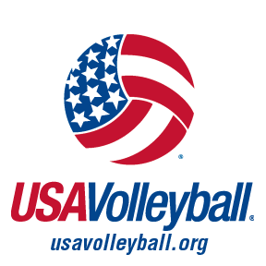
Grassroots Outreach Grants
Overview:
This grant is available to USA Volleyball Regional Volleyball Associations, clubs, grassroots programs or individuals that wish to further training of coaches, players, and/or parents through clinics or various programming. Examples of programming might include presenting or exhibiting at the national coaches’ conference. The recipients to receive funding will be selected through an application process.
Award: Up to $5,000 may be rewarded. Recipients will be required to submit reports detailing the use of funds. Funds will be allocated directly to the club, region or individual responsible for the programming. Documentation of the event must be submitted in a timely manner to USA Volleyball. Noncompliance may result in repayment of grant funds to USA Volleyball.
Application Process:
Please answer the following questions:
What will the name of the event/program be?
Who is the targeted audience? (Select all that apply).
Junior Adult Coaching Grassroots Beach/Sand/Doubles Boys
Sitting Programming Equipment/Facility SafeSport Officials Other/
When will the event/programming take place?
How many people do you plan on participating?
What is the goal for this program/event?
What type of advertising will be done to promote this event/program?
How much grant money are you requesting for this project?
After the program/clinic/training, etc. which of the following would the grant recipient submit:
Photos Videos Presentation Shown Handouts Given
A Report to Share with other RVAs
If you are a club, individual, or grassroots program you must also submit a letter of support from your USA Volleyball Region.

Please explain in detail how the grant monies will be spent:
*This is a sample chart, edit the chart text with your information then enter costs.
Program Information | Admin Fees | Court Cost | PR/Marketing | Awards/Give-A-Ways/Shirts | Site Director | Officials | Total
Education Skills Clinic
Area Championships
Summer Open Gyms
Total

We will work with you through this grant process to help meet your needs, to grow your programming and enhance your membership.
Grant requests will be handled on a first come, first served basis until the monies are distributed. Please send completed applications and any questions to GrowGrants@usav.org.

